Mountaineer Safety Officer Teleconference - Thursday, 23 June 7:00pm -8:00pm

WHITEBOARD

Expected participants: Dave Shema, Doug Sanders (Everett), Tony Tsuboi (Everett), Dick Lambe (Foothills), Cheryl Talbert (Global Adventures), Tom Pearson (Olympia), Helen Arntson (Seattle), Raphael Giangiulio (Tacoma)
Maybe: James Pierson (Bellingham)

Proposed Agenda

- Display of Incident reports on trip webpage - FIXED

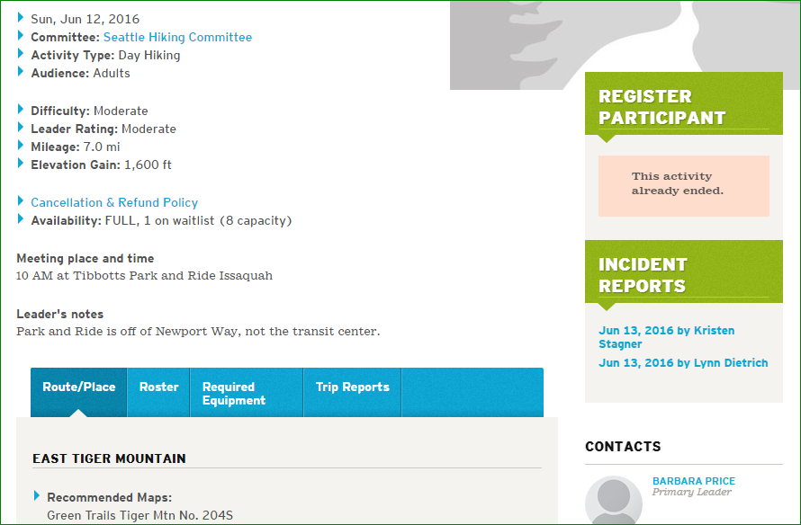

Trip page is public. Should not be displayed?
Is of value as an historical record.
Dragontail climb is an example of an incident that should not be shown. Agree

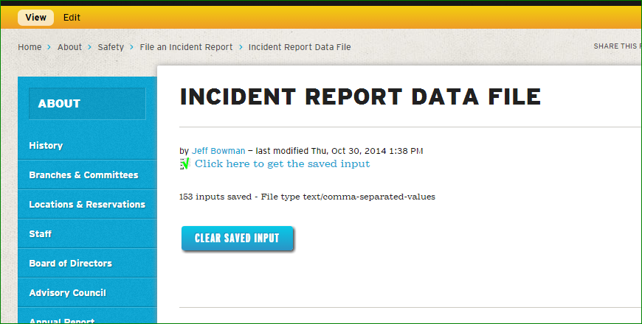

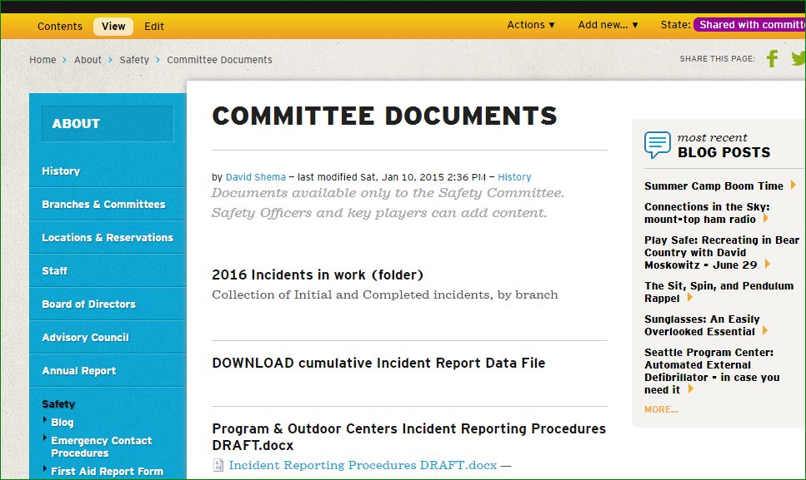

- Text added to Trip and Field Trip “safety Concern” question. DONE.
Doug and Helen suggest having a single form. So, ask that all activities direct concerns to an incident report.

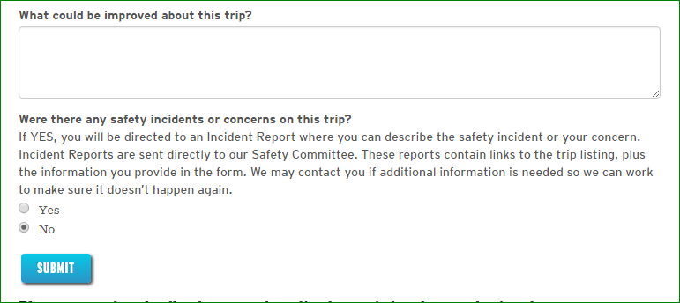

- What to do about overdue party? Call Mntr Emergency Number or 911? When?
Leader should determine “When”
Tony has a document with thoughts about this. He will send out.
I will contact Carolyn.

- What SHOULD the Safety Committee be doing? Is annual Safety Report worth the effort?
Helen - Annual report is important, especially the gathering of information
Doug - We should submit our annual report to the Board.
Tom - Separate in major and minor sections
Spend more time analyzing for trends based on activity and send only to the appropriate committee. Summarize a few big incidents but the other information is in the form of “core learnings”.
Blog for annual report, Summarize

Doug: While we are not subject to WISHA’s requirements for occupational safety committees they are followed by 1,000’s of employers and may provide some guidance. Normally, the committee would be made up of management and employees. Management would follow-up as they felt appropriate.

http://www.lni.wa.gov/safety/rules/chapter/800/?F=M

Modified a bit.
- Review safety reports to help correct safety hazards.
- Evaluate the accident investigations to determine if the cause(s) were identified and corrected.
- Evaluate safety program and discuss recommendations for improvement.

What I am not seeing being done are SC observations and recommendations being sent to responsible parties.

Dick Lambe:
What the Safety Committee should be doing
(Suggested June 23, 2016 by Dick Lambe)

 | Action
1 | Gather information on safety incidents
2 | Organize and categorize safety incidents
3 | Analyze safety incidents, looking for patterns  For example: very few slips and falls on snow and ice involve use of crampons
4 | Prepare suggestions on possible steps to improve safety.  For example: include crampon training in scramble course
5 | Prepare sub-reports of safety incidents, organized by activity, and provide to activity chairs along with any safety suggestions for their activity.  For example, backpacking committee chairs would receive reports limited to safety incidents on backpacking trips.  Designate one member of safety committee as liaison for each activity type.
6 | Follow up with activity chairs, to see what action they have taken in response to information on incidents, patterns and suggestions

- Status of incident report processing?
- Anything else?
  - Dick: Is is possible to stop spam sent to the Mountaineers Safety Committee List, perhaps by limited senders to registered users?

